Doomsday Meteorite
Everything's better with e1m1 music.

Game Objective: SURVIVE!
It’s simple - survive as long as possible in increasingly difficult meteorite-waterfall
controls: ( WSAD & Space - move and jump ) (mouse to look around)

“Git Gut”
You can surpass your record from previous attempts:


Use the Cakes to enhance your capabilities
Try them all and experience:
- Well-Fed Barrier: to protect you from incoming meteorite
- Super Mario the Cake: to give the meteorites some of their own medicine
- Yummy: Some are so tasty to give you more health
- Snow Cake: Increases your overall movement-speed.
- The New Agenda Cake: Everything is better as a rainbow! Makes the meteorites harmless for a change.
- The Cake: Sometimes you just have to embrace the taste.

Staring Game Objects:

- Health Bar

- Your Golem

- the Doom Guy
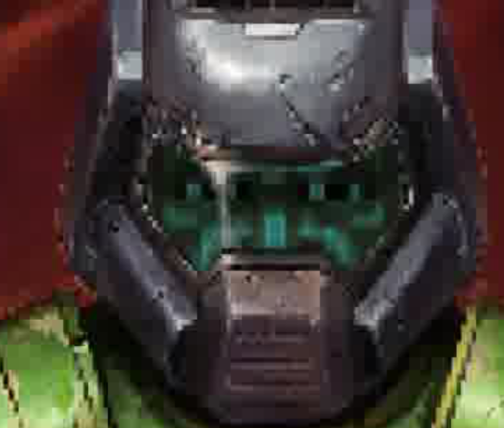
- e1m1.mp3
the music!
- CAKES

- MORE CAKES

- Meteorites…

- Server that is not available

- Menu and Post-game menu
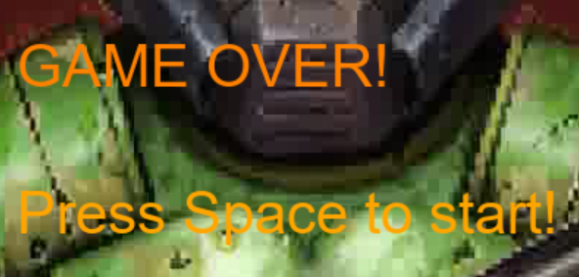
- Score meter!

- Don't fall the platform

- The edge of the window that will let you fall for eternity. Escape the meteorites with style.

The game:
